TECUMSEH SHORELINE MINOR HOCKEY ASSOCIATION
(“TSMHA” or “the Corporation”)
NOTICE OFANNUAL GENERAL MEETING
OF THE MEMBERS OF TSMHA
MARCH 25th, 2017
TO: Members of TSMHA
AND TO: The Auditors of the Corporation, BDO Dunwoody LLP

TAKE NOTICE that a meeting of the Members of the Corporation, being the ANNUAL GENERAL MEMBERSHIP MEETING, will be held on Saturday, the 25th day of March, 2017 at 9:30 am in the forenoon (Eastern Daylight Time) at Royal Canadian Legion, 12326 Lanoue St. (Corner of Lanoue and Lesperance Rd.), Tecumseh, Ontario, for the following purposes:
1. To consider and, if thought appropriate, to approve, with or without amendment, the Minutes of the last Annual General Meeting of TSMHA, held Saturday, March 26th , 2016. Copies of the aforesaid Minutes may be obtained on Corporation’s website. (Copies WILL NOT be available at the meeting);
2. To receive and consider, and if thought appropriate, to approve the audited financial statements of the Corporation for the fiscal years ended April 30, 2016 and the report of the auditors, BDO Dunwoody LLP thereon; The financial statements and report of the auditors may be obtained by contacting the Treasurer of the Corporation at treasurer@tsmha.net directly and requesting a copy. (Copies WILL NOT be available at the meeting);
3. To appoint auditors for the Corporation for the ensuing fiscal year of the Corporation;
4. To receive a preliminary management prepared financial report for the current hockey season (2015-16) which, when the books for which are finally closed off (on April 30, 2016) will be audited by the Auditors of the Corporation for further report to the membership;
5. To elect Directors for the Corporation to fill vacancies for directors for the ensuing fiscal year of the Corporation. The following persons have been nominated:
A. Carlo Derose
B. Sean Moor
C. Trish Currie
D. Charles Casio
D. Amanda Belanger
E. Dino Caro
F. Dan Palanca
G. Chris Truppe
H. Ben Peltenburg
I. Mark Horrocks

There are 6 vacancies for Director of the Corporation to be filled at the meeting. The candidates obtaining the highest number of votes will receive two (2) year terms.
6. To approve and confirm all by-laws, contracts, acts and proceedings of the directors of the Corporation, enacted, made, done or taken since the last transaction of annual business of the Corporation;
7. To transact such further and other business as may properly come before the meeting or any adjournments thereof.
DATED at Tecumseh, Ontario, this 28th day of February, 2017

BY ORDER OF THE BOARD,
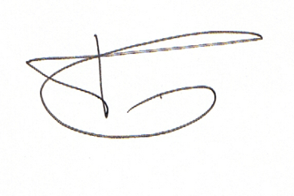

Pete Morassutti, President

